**Academic Pathway Optimization**

Goodfellas

IS436 - 03

Deliverable 1

February 20th, 2019

**Project Members**

Paul Lyon

Tanner Yatsko

Jas Singh

Zach Jaquet

Benjamin Wang

Densu Kurian

William Chanmugam

Niels Verhoeven

**System Request**

**Project Name:** Academic Pathway Optimization

**Project Sponsor**

Organization: University of Maryland, Baltimore County (UMBC)

Address: 1000 Hilltop Circle, Baltimore, MD 21250

Phone: (410) 455-1000

Email: [admissions@umbc.edu](mailto:admissions@umbc.edu)

**Business Need**

**Background:** Potential students looking to continue their education into college must decide on a major/minors and select course paths in order to graduate with direction and in a reasonable timeframe. UMBC Admissions Office provides a service in helping students select those majors and also the course paths. It is a service that UMBC and many other universities offer. While these services are offered, students also have their motives as to what majors they would consider (interests, potential salary, difficulty, etc.).

**Business Opportunity:** A service/application can be developed that can provide a more personal look into offered majors, course paths, and associated difficulties. It can get a feel for what a student wants and likes about certain programs to allow them to decide for themselves. Providing this service can also take loads of work off of school staff.

**Business Objectives:** It is the full intention to provide the student with an interactive application that allows the student to ask questions, research, and map out a major/minors that is right for them and also provide them with the direction on how to complete the associated programs. With this application showing which courses would be recommended for the students to select the easiest, yet most rewarding course path.

**Business Value:** Reduction in people switching majors, reduction is “undecided” majors, Increase in graduation rate, decrease in debt of students overall

**Business Need:** Increase access to information and give students a resource to see what is best for them

**Business Requirements:** Capture student demographics and include search capabilities for each field

**Special Issues and Constraints:**Need a lot of stats and information, need to be updated frequently and as per the need of each college or university

**Feasibility Analysis**

**Technical Feasibility:**

**Tech Stack:**

A Django/SQL and jQuery stack was chosen for this project. This is because there is a high familiarity of this stack within our development team. A bleeding edge framework not necessary for this project. Django and jQuery are tried and true web development tools. Their widespread use will also allow the UMBC faculty to take over during the maintenance phase.

**User Experience:**

All University end-users are already familiar with web-based tools. myUMBC and Peoplesoft already have complete adoption within the UMBC IT system. Creating a web-based tool as opposed to a standalone application allows for simple integration into these existing web-based frameworks. The finished project can be hosted on existing hardware within the University system.

**Project Size:**

Fairly basic features offered are offered by this tool. Viewing the output of *Academic Pathway Optimization Algorithm,* and a simple administrator interface to update grade distributions manually (typically grade distributions would be fetched automatically), are all that is needed to complete the project. A team of 5-6 developers can expect to finish project in a semester.

**Economic Feasibility:**

**Summary:**

In development of the Academic Pathway Optimization tool for students to facilitate finding a desired pathway due to their personal interest criteria. In doing so we have a team of eight proficiently qualified individuals sponsored by UMBC on contract in order to make this optimization tool come fruition. The economic feasibility analysis below will provide a granular understanding of how each individual cost will be in consideration of how this project will be built in terms of financials and economic assessment.

**Cost and Benefits:**

**Assumptions:**

* We are working full-time, contracted over a one year period as a team.
* These cost all pertain to the timeline of 1 year.
* Costs are being paid by sponsorship (UMBC).

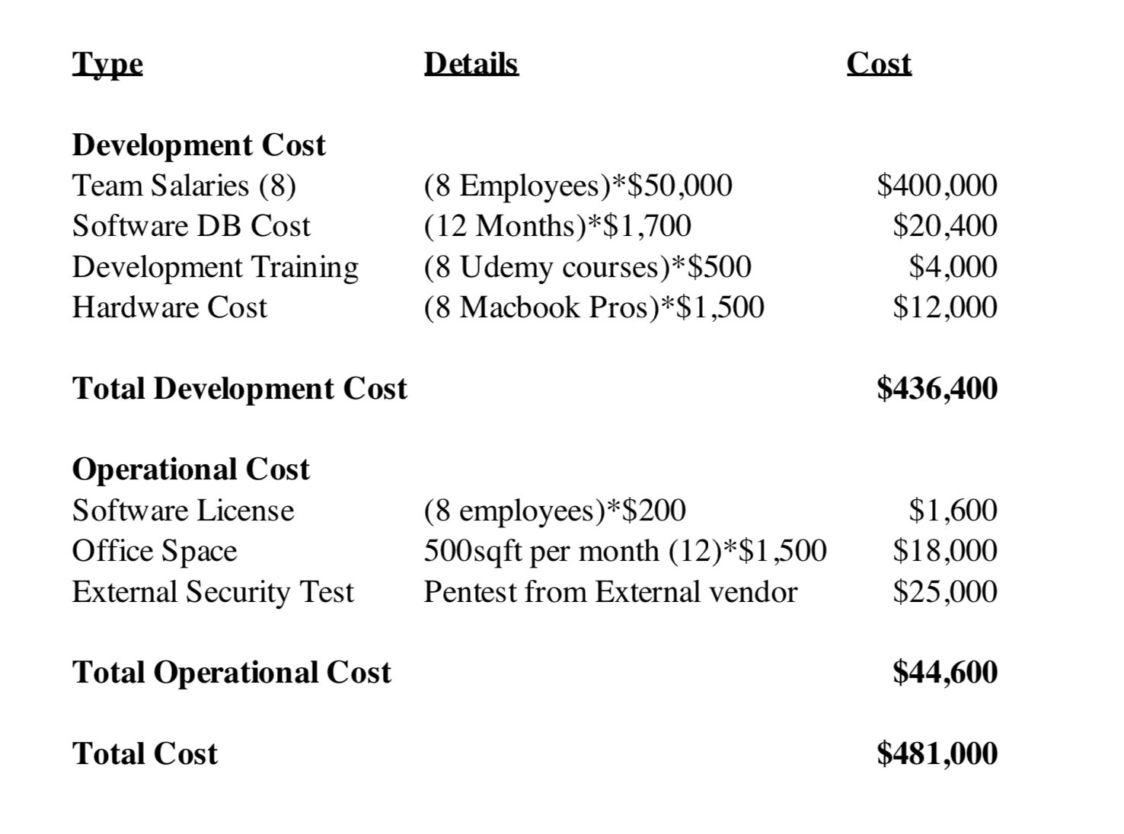

**Tangible:** This provided service can eliminate costs in staffing and additional resources needed to work as closely to the student as are typically needed.

**Intangible:** This provided service can provide the ability for the student to make self-determinations. They receive the power to research programs without any potential bias from administrators and the security of making their own choices.

**Organizational Feasibility:**

**Management prowess:**

It is believed with confidence that the product can be developed efficiently. The team combined, there is a wide spread of experience and skills throughout the team that makes this a reasonable undertaking. In addition, the size of the project is manageable given the amount of members participating in the project.

**Resource Sufficiency:**

The real-world experience of members of the team is a large resource that provides large benefit. When identifying the most essential non-financial resources it can be seen that we have good sources of information when it comes to each aspect of application development and the project’s needs.

**Strategic alignment:**

This project will help further UMBC’s goal of helping students graduate. Our software will help guide students in their choice of major through a series of specialized survey questions.

**Target users:**

Incoming freshmen and other students unsure about what major they want to choose.